Create the Database
CREATE DATABASE CompanyDB;

Use the Database
USE CompanyDB;

Create the Employees Table
CREATE TABLE Employees
(
EmployeeID INT AUTO_INCREMENT PRIMARY KEY,
FirstName VARCHAR(50),
LastName VARCHAR(50),
DepartmentID INT,
Salary DECIMAL(10,2),
JoinDate DATE
);

Insert Sample Data
INSERT INTO Employees
(FirstName, LastName, DepartmentID, Salary, JoinDate)
VALUES
('John','Smith',1,50000,'2022-01-10'),
('Alice','Brown',2,60000,'2021-03-15'),
('David','Wilson',1,55000,'2023-06-20'),
('Emma','Taylor',3,70000,'2020-08-05');

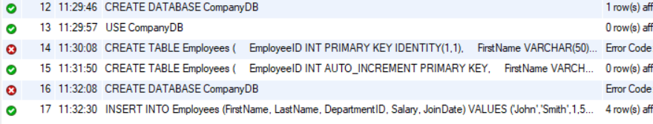

Stored Procedure in MySQL - MySQL uses a different syntax for stored procedures.
DELIMITER $$
CREATE PROCEDURE sp_GetEmployeesByDepartment
(
IN p_DepartmentID INT
)
BEGIN
SELECT *
FROM Employees
WHERE DepartmentID = p_DepartmentID;
END $$
DELIMITER ;
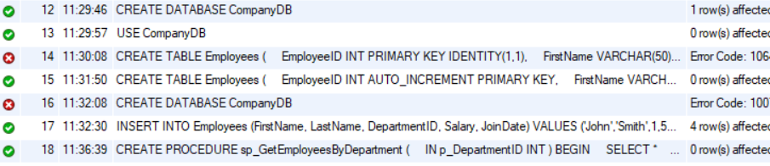

CALL sp_GetEmployeesByDepartment(1);
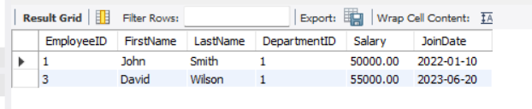
Insert Employee Stored Procedure (MySQL)
DELIMITER $$
CREATE PROCEDURE sp_InsertEmployee
(
IN p_FirstName VARCHAR(50),
IN p_LastName VARCHAR(50),
IN p_DepartmentID INT,
IN p_Salary DECIMAL(10,2),
IN p_JoinDate DATE
)
BEGIN
INSERT INTO Employees
(
FirstName,
LastName,
DepartmentID,
Salary,
JoinDate
)
VALUES
(
p_FirstName,
p_LastName,
p_DepartmentID,
p_Salary,
p_JoinDate
);
END $$
DELIMITER ;

CALL sp_InsertEmployee
(
'Rahul',
'Sharma',
2,
65000,
'2024-01-15'
);

